en

Menu
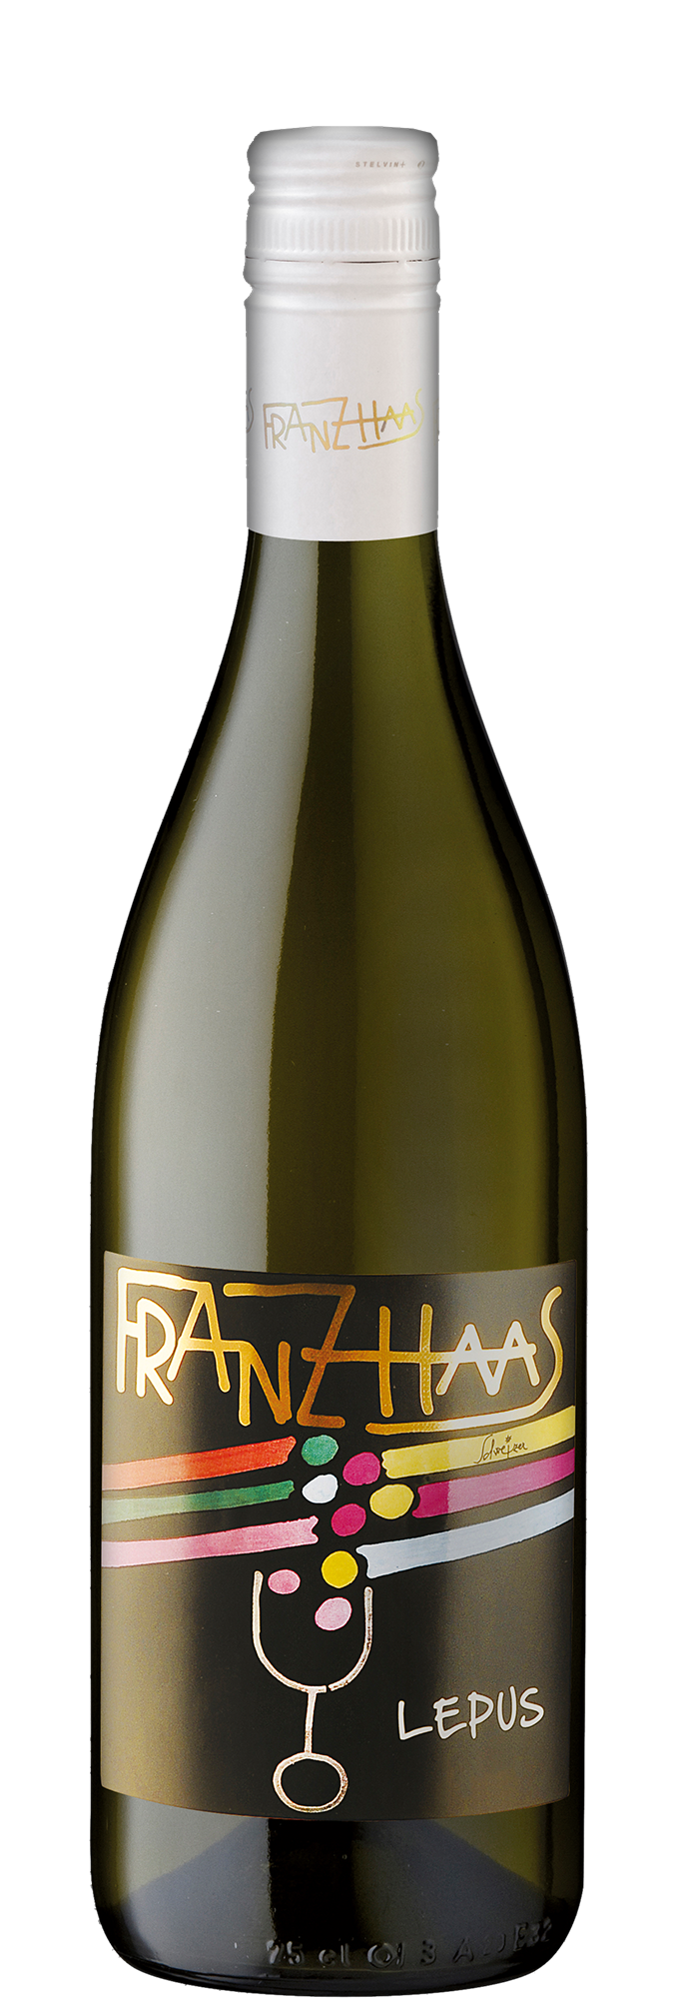

Pinot Bianco Lepus
The Pinot Bianco has a straw, shiny yellow color. The perfume recalls fruity and spicy notes that remind us of ripe apples, wildflowers and fresh bread. On the palate, it is distinguished by a definite personality accompanied by an elegant and robust structure, a harmonious acidity and ending with richness and persistency. The Pinot Bianco needs to mature for at least three to four months in the bottle to express its typical bouquet and complex characteristics.

Characteristics
Yield per hectare
60 hectoliters
Production
20.000 - 25.000 bottles
Recommended serving temperature
14° C - 16° C

Production area
The Pinot Bianco vines are cultivated with the Guyot system in areas located between 400 and 800 meters above sea level. In the soil of this area you can find the different geological properties of the region, from the lighter sands to the heaviest porphyry erosion soils. Exposures range from south to southwest.

Winemaking
The must is mainly fermented at a controlled temperature in stainless steel tanks and partly in barrique. Before bottling, the wine ages on its lees for about five months to acquire complexity and full substance.

Food Pairing
The wine can be served with a variety of dishes, ranging from meaty starters to pasta dishes, rice and fish with or without sauces, to light Asian and spicy curry dishes.

