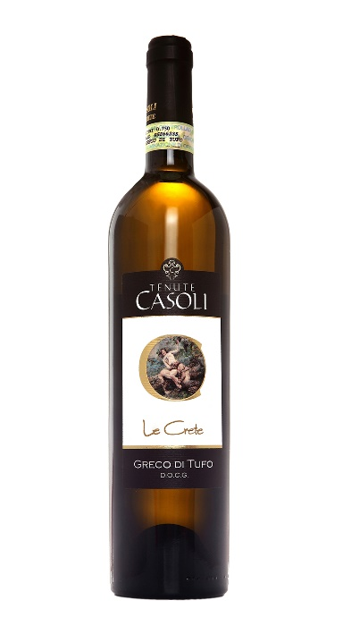
Tenute Casoli ‘Le Crete’
GRECO DI TUFO
Denominazione di origine controllata e garantita
Last commercialized vintage: 2016
Bottles produced: 8000
Grape variety: greco 100%
Area of production: Tufo, Montefusco, Santa Paolina - 400 / 500 mt s.l.m.
Soil: chalcky-clay
Training system: Guyot
Yield: 80 quintals
Harvest: third/fourth week of October
Hand-picked grapes
Wine Making
Winemaking process: soft crushing of destemmed grapes in pneumatic press inertized with nitrogen; cryomaceration
Fermentation: in Stainless steel tanks at controlled temperature lower then 20 °C
Ageing: in Stainless Steel tanks for 3/4 months sur lies with frequent batonnages; then in bottles for at least 2 months
Serving temperature: 10 - 12 °C
Alcohol content: 12,5%

