Friulano
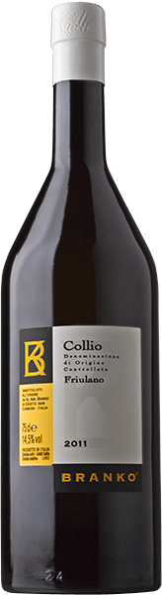
Genuinely Friulian, by history, lineage and emotional resonance, the Friulano grape keeps its pledge to deliver a generous, warm drinking experience to which time adds personality and new dimensions of sensory gratification. The instantly recognisable array of bitter almondsedged aromatics frames an outstandingly fresh-tasting palate, the result of maturation in stainless steel subtly enhanced by a small proportion of wine conditioned in 400-litre oak casks.

